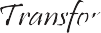

Community Development Project
On

Creating awareness about old age people And

Single Parent Child

Submitted By:
Sam Pravardhan V
Registration Number:
12217383

In partial fulfilment for the requirement of the award of the degree of
Sahara Ngo

Lovely professional University Phagwara, Punjab.




1.
2.
3.
4.
5.
6.
7.
8.
9.
10.
11.
Certification by the Ngo
About the Ngo
Title and aim of the project
Introduction
Problem identification for old people Cause of the problem for old people
Problem identification for single parent children Cause of the problem for single parent children Objective
Steps taken to achieve the objective
Conclusion



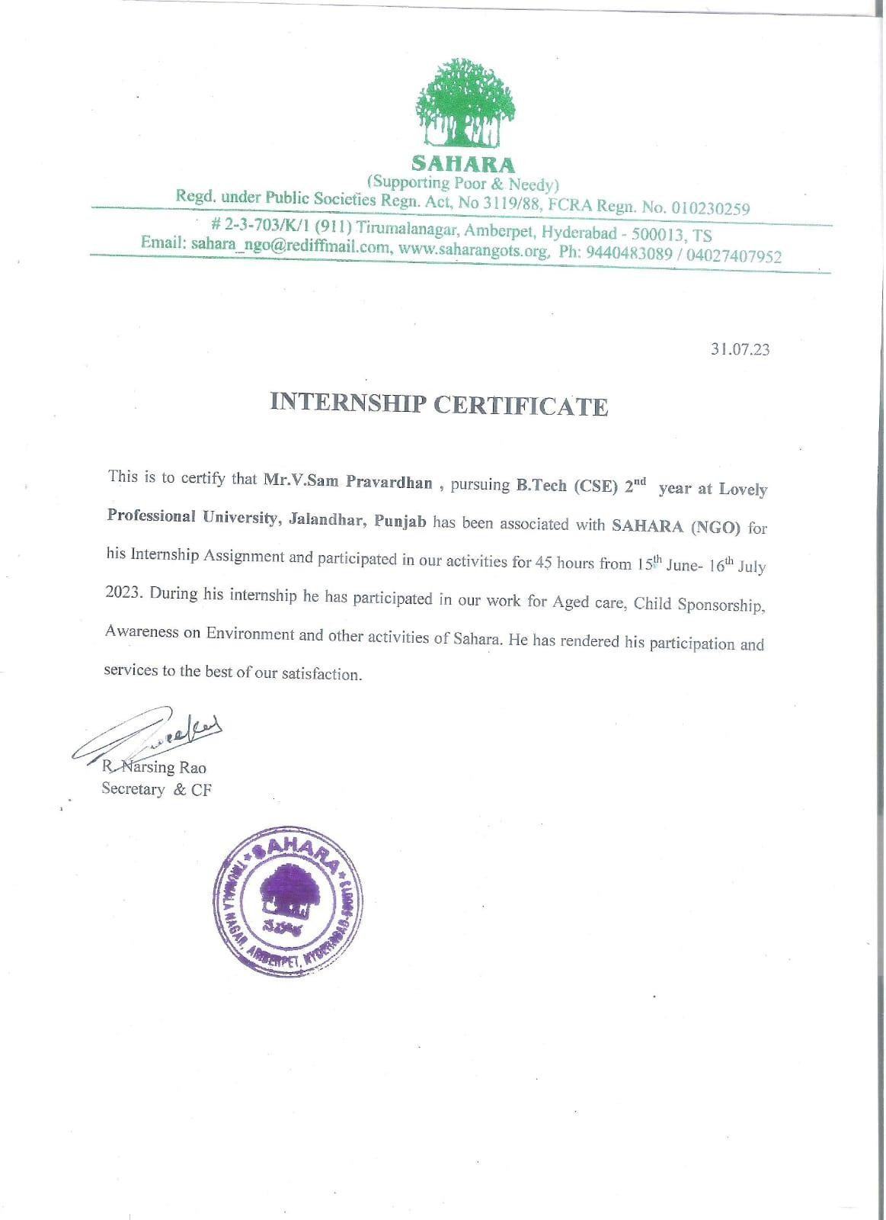


About the Ngo

Sahara was established on 1986 and mainly aims for old age and needy people.
Sahara has been working under the guidance of the president T N Balamukund and Secretary Late R Narsing Rao.


Since the Past 36 years, Sahara has been working for the improving
the quality of life, especially the underprivileged sections of the society. Their focus groups have been the elderly, children, women and youth. Through their activities, they tried their best to see that the elders in the project area have
been taken care of best possible way. At the same time, they support to children to help them continue their education has been strengthened. Women have
been major benefactors over the past years, with implemented successfully. Awareness campaigns on health issues pertaining to the area have been carried on; their focus in the last year has been covid prevention, post covid health
issues, menstrual hygiene.

Their vision is to build a society where every individual is able to live a
life of dignity and respect, with equal access to opportunities and resources. We strive to create an inclusive and tolerant society where everyone can realize their potential regardless of their background or circumstances.


Title of the project:
Creating awareness about old people and single parent child


Aim:


The aim of this project is to create an awareness about old age people in
the younger generations, so that the younger generation give the respect to the old people at least from their home and single parent child who have lost their father or mother.

Objectives of the project:


- To learn why the old people are neglected by their family members
- To learn why the child has lost their parent and how the parent is
going to bring up the child in what kind of circumstances


Introduction:

"Old age" and "single parenthood" are two topics that might not seem very
relatable, but in reality, many older people have to face the challenges of
parenthood alone due to the loss of their partners. This creates unique struggles, and in some cases, single-parent households can even face stigmatization and
discrimination from society.


Another important aspect of this workshop is creating awareness among the
younger generation about these issues. We live in a fast-paced world where technology has taken over our daily lives, and it's easy to forget the challenges that people in older generations and single-parent households face on a daily basis. By educating and empowering younger generations to be more aware of these issues and the different ways they can support their elders and single-
parent households, we can create a society that is more inclusive and compassionate.


In this project report, we will explore the challenges that single-parent
households face and how we can support them in our communities. We will also learn about the experiences and needs of older persons and explore the issues surrounding ageism. By the end of this report, we will have a better
understanding of these two important issues and ways that we can make a positive impact in our community.

Problem identification for old people:

1. Loneliness and social isolation: As people age, it can be become more
difficult to maintain social connections and engage with their communities. This can result in the feelings of loneliness and isolation, which can have a significant impact on mental and physical health.
2. Financial stability: Many older people rely on fixed incomes, which can be a source of stress and financial instability. This can be exacerbated by
increased healthcare costs, rising housing and food prices, and other
factors.
3. Health crises: Older people are at increased risk of developing chronic
health conditions, such heart disease, diabetes, and cancer. They may also experience age-related changes in their physical and mental capabilities, which can create additional challenges related to health, mobility, and
independence.


Cause of the problem:
1. Loneliness and social isolation: Changes in social networks, such as the loss of close friends and family members, can contribute to isolation.
Additionally, limited mobility and a decline in physical and cognitive abilities can make it difficult for older people to participate in social activities and engage with their communities.

2. Financial instability: Fixed incomes, health expenses, and rising costs of living can make it challenging to maintain financial stability. Additionally, changes in the labour market, such as age discrimination can make it
difficult for older workers to stay employed and earn a steady income.


3. Health crises: Age related changes in the physical and cognitive abilities, chronic health conditions, environment factors, genetic and other individual and societal factors can all contribute to health crises in older adults.


*Note: Here, from this observation I came to observe that most of the children of
old people think that their parents are a burden to be taken care of and forgetting the fact that they were brought up by their parents and they owe them their lives.

Problems faced by single parent child:

1. Financial stability: The burden of providing for a family fall solely on the
single parent, which can make it challenging to maintain financial stability. This can result in stress, anxiety, and feelings of insecurity.

2. Lack of social and emotional support: A single parent may not have the same level of social support that two-parent households have, which can create additional stress and responsibility for the parent. This can also impact the child’s emotional development and sense of belonging.


3. Challenges in education: Children raised by single parents may face
additional challenges in their education. For example, parents may have limited time and resources to support their children's academic
achievements, or there may be a lack of parent-teacher communication and involvement.


Cause of the problem:

1. Financial Stability: In normal households where both of the parents are employed which makes it easy to give their child a peaceful life, but where as in the case we are working on the single parent has to taken on
everything by themselves and its not an easy task.


2. Lack of social and emotional support: Most of the single parents are
mothers who have lost their husbands. On my opinion, its not any easy
thing to move on after losing your life partner and on top of that taking care of a child is definitely not an easy task. The wives who have lost their
husbands have the same cause of death mostly that is either dead on duty or health issues.
3. Challenges in education: If you think about the perspective of the child who have lost their father/mother would definitely not be normal. Many of the parent die when their children are in still childhood stage and wont remember but as they grew older at some point they would think about
their parent who have lost their lives. And the child will feel uneasy when he come across the children playing with their parents.

Objective to be achieved:
The objective of this project is to create awareness and promote understanding
about the issues faced by older people and children raised by single parents in society. The specific goals include educating young people about the challenges and needs of older people and single parents, supporting older people and single parents through community services and programs, encouraging community members to engage in advocacy efforts, creating a more inclusive and supportive environment, promoting research and evidence-based approaches, and
advocating for policies and programs that support their well-being.

Various steps taken to achieve the objective:
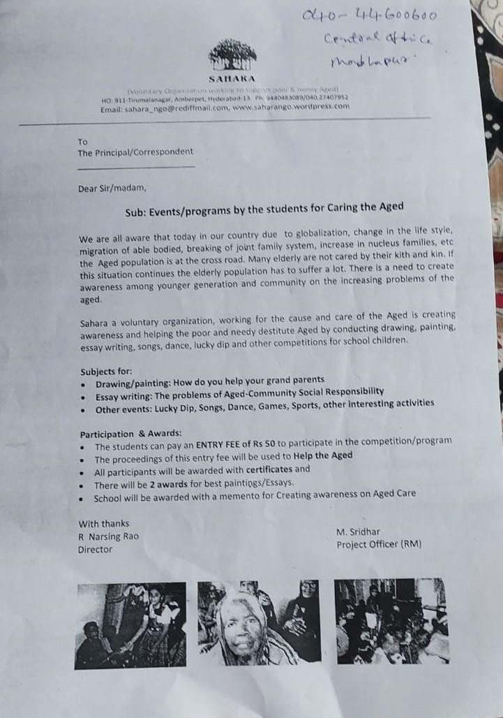
After taking this project our sir who has given the project has said to visit schools
in my locality and give them this appeal.

This appeal was given to all the schools nearby our locality. The schools that we went and their responses were listed accordingly below:
- On 18th June we went to Lotus lap public school in dilsuknagar, Hyderabad. Response: Will call you later.
- On 18th June we went to Narayana concept school in dilsuknagar, Hyderabad.
Response: They have their own way conducting.
- On 19th June we went to G. Pulla Reddy memorial school in dilsuknagar, Hyderabad.
Response: Will call after informing to higher ups.
- On 20th June we went to Dwarakami model high school in RK puram, Hyderabad.
Response: Come after a month because its Unit test 1 time.
- On 22th June we went to Mother Teresa grammar high school, Rk puram, Hyderabad.


- On 26th June we went to Krishnaveni talent high school in dilsuknagar,
Hyderabad.
Response: Will conduct by the end of this month and inform you.
- On 29th June we went to St. Thomas high school in salivahnanagar, Hyderabad.
Response: Will conduct after informing the students in the assembly.
- On 29th June we went to Bhashyam model high school in salivahnanagar, Hyderabad.
Response: As per their management they will not allow.
This what we have done to collect money and help old age people and the
We have also participated in the event that Sahara conducts every last Saturday of the month for old people
Response: will conduct by the end of this month.

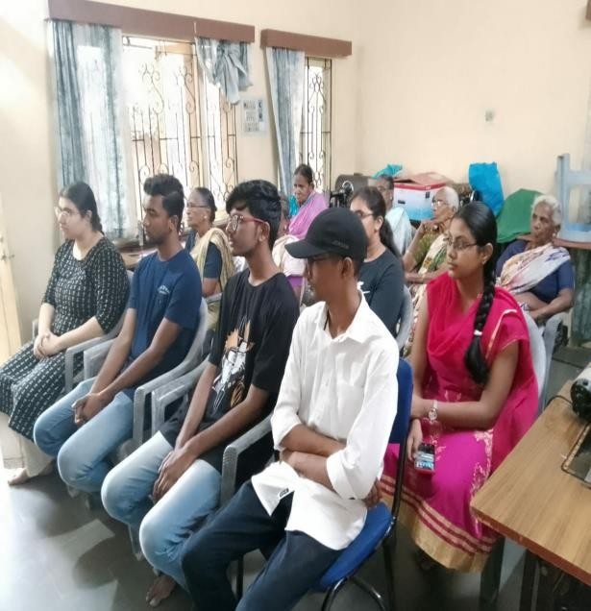
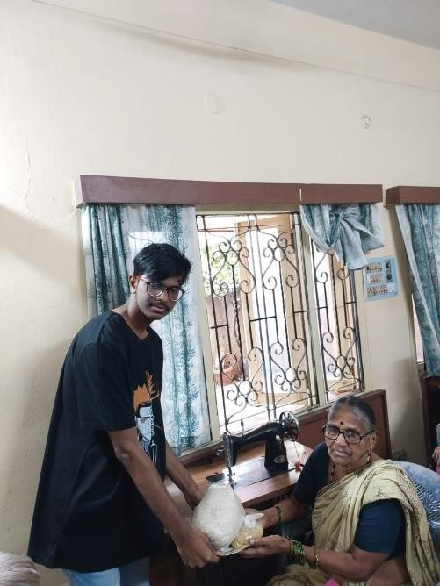

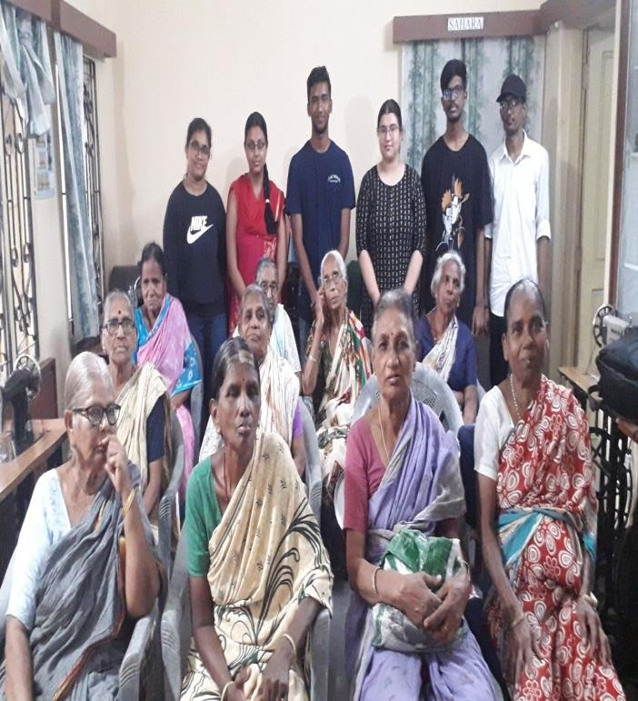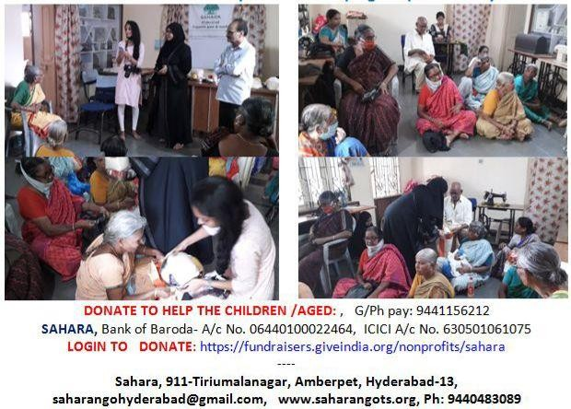

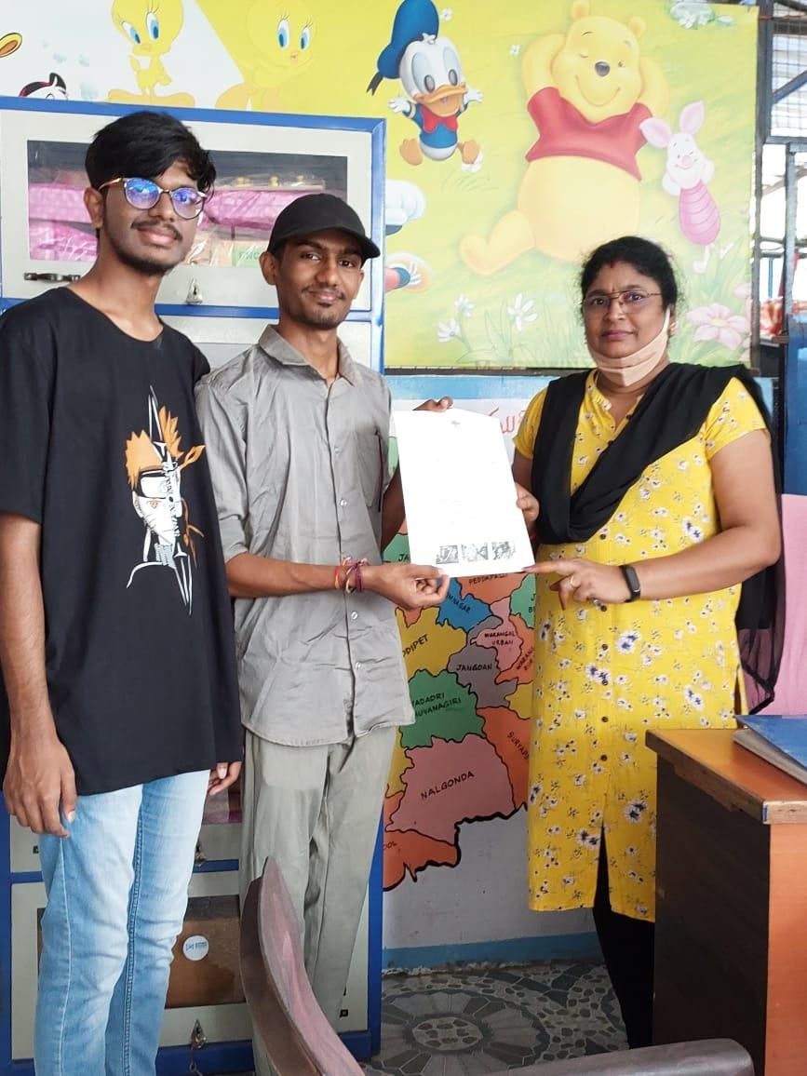
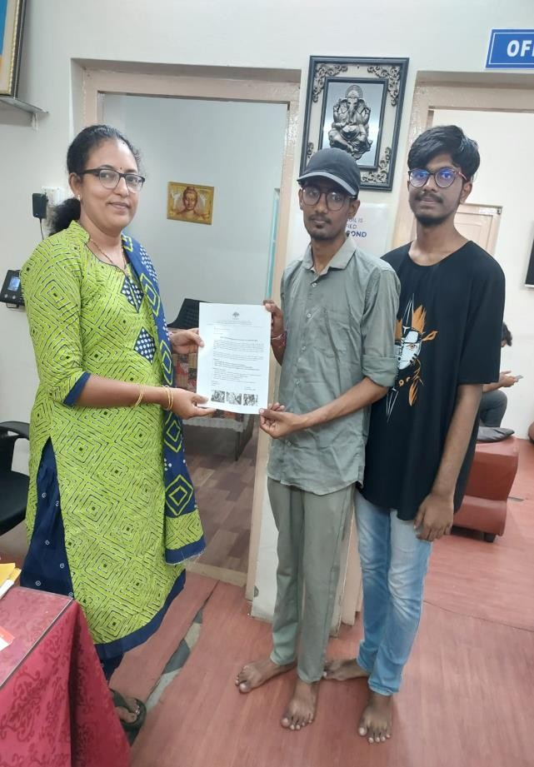

This is what we have done for old people. Now coming to single parent children, we have created an online google document.
https://forms.gle/sRtzkqQ7HXYv63be8

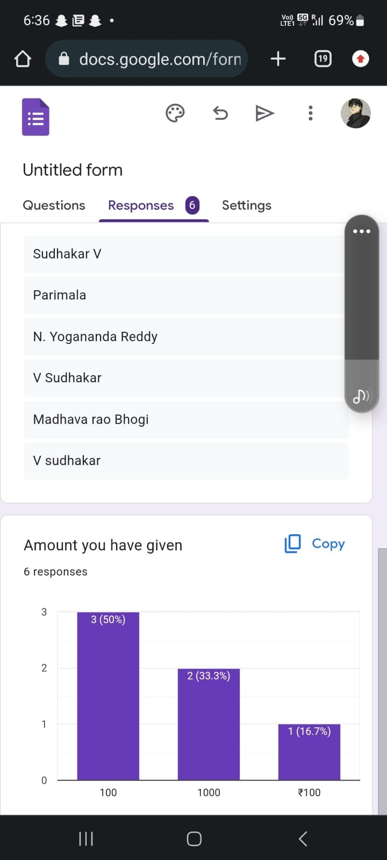

Through this google documents we have collected 2400 rupees for single parent children.

Conclusion:
In conclusion, the objective of this project is to create awareness and promote understanding about the issues faced by older people and children raised by single parents in society, in order to empower communities and create a more inclusive and supportive environment for everyone.

One of the main challenges faced by older people and single parents is financial
instability, which can be exacerbated by the lack of social support and rising costs of living. Through this project, we aim to raise awareness and promote resources that address their financial needs, such as affordable healthcare and housing,
legal support, and social security programs.

Another challenge is social stigma and discrimination, which can make it difficult for older people and single parents to access support and services. Through this project, we aim to create an accepting and understanding community that breaks down stereotypes and reduces stigma for those who are marginalized and
overlooked.

Additionally, we aim to empower young people through education about the challenges of aging and raising children as a single parent, in order to promote empathy and understanding. By encouraging community members to engage in
advocacy efforts, we aim to create a more inclusive and supportive environment, where all members of society can live with dignity and respect.

In summary, this project is an important step towards creating a more inclusive and supportive society, where everyone can live with dignity and respect. By
raising awareness and promoting resources, advocacy, and research, we can help empower communities and create a world where all members of society can live fulfilled lives.

